SOP
- Please take 1 set of each component – 1/8’ push-in connectors, 3/8’ elbow connectors, rods, end plates, insulators, current collectors, cooling fin, spacer, bipolar plate and MEA
- Open the packaging and check on the quality and of the component. Make sure everything is in good condition – no deformation, break, scratch, holes or defects.
- Make sure that the quantity of the components as below:
- push-in connectors: 2
- elbow connectors: 2
- rods: 10
- end plates: 2 (top and bottom)
- insulators: 2
- current collectors: 2
- cooling fin: 23
- spacer: 46
- bipolar plate: 44
- MEA: 22
- Align the current collector to the end plate and label the edge of the current collector using marker pen for all 4 corners. Label both top and bottom plate.
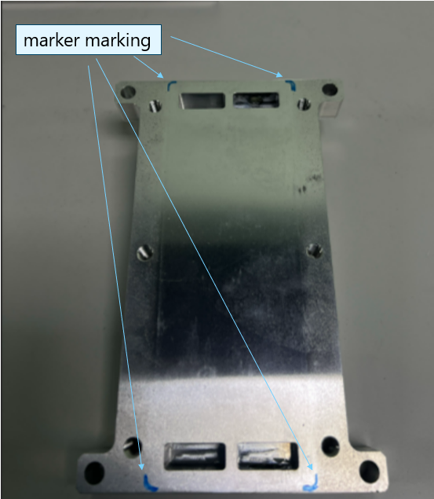
- Take a Teflon tape and wrap around 1/8’ push-in connectors and 3/8’ elbow connectors. Wrap 2 full round of tape on to the thread section.
- Tighten the 1/8’ push-in connectors and 3/8’ elbow connectors to the top and bottom plate (as in the picture below).
- Take 10 rods and screw into the bottom plate until the rod indicator (as picture)
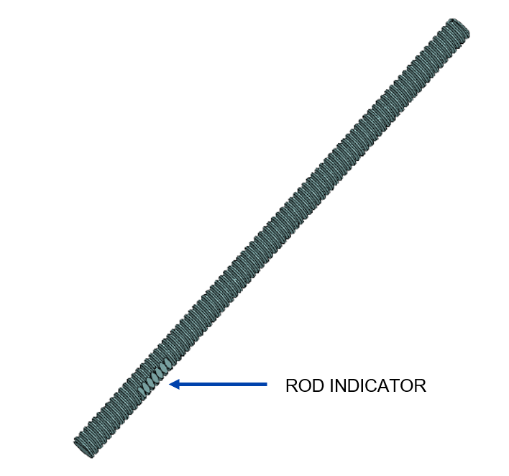
- Pre-stacking jig

